Business Case: Netflix - Data Exploration and Visualisation

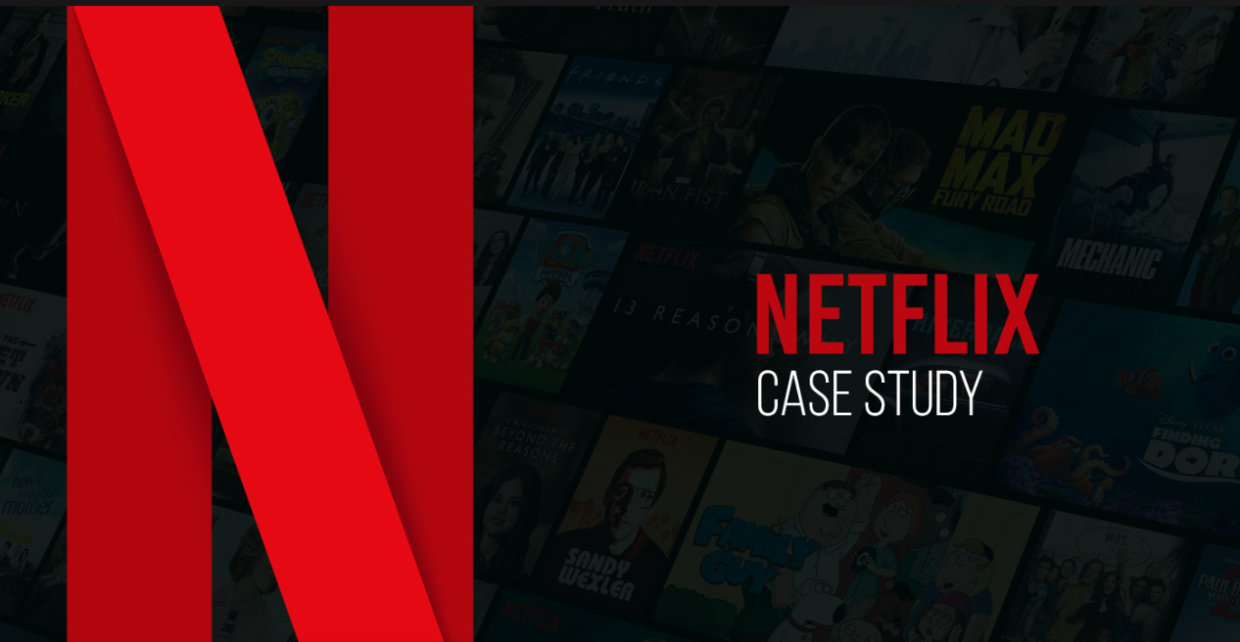

Introduction
As one of the leading media and video streaming platforms globally, Netflix has revolutionized how audiences consume entertainment. With a vast library of over 10,000 movies and TV shows and a subscriber base exceeding 22 million as of mid-2021, Netflix continually seeks innovative ways to enhance viewer engagement and optimize its content offerings. This case study aims to analyse the Netflix dataset to uncover valuable insights that can inform strategic decisions regarding content production. By understanding viewer preferences and trends in various markets, Netflix can identify which types of shows and movies resonate most with audiences, ultimately facilitating targeted growth strategies in different countries. Through this analysis, we aim to provide actionable recommendations that could support Netflix in its mission to deliver compelling content while maximizing subscriber satisfaction and retention.

Let’s get Right into it:
The content on Netflix can be broadly categorized into two primary sets: movies and TV shows. To gain insights into the distribution between these two categories, let's examine the following chart.

Insight 1
The chart indicates that movies on Netflix outnumber TV shows by nearly double. This trend suggests a strategic focus on film production and acquisition, likely aimed at appealing to a broader audience seeking quick, self-contained entertainment. However, to enhance viewer engagement and retention, Netflix may benefit from increasing its investment in original series and popular TV genres, ensuring a balanced and diverse content library.
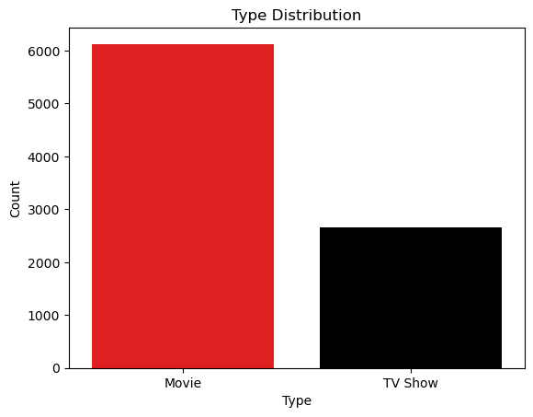
*As this is a business case study on Netflix, you will notice that all the charts and this document utilize traditional Netflix colors (basically just red and black)
Let’s examine how the popularity of both formats has evolved over the last 30 years, based on the release dates of content available on Netflix:

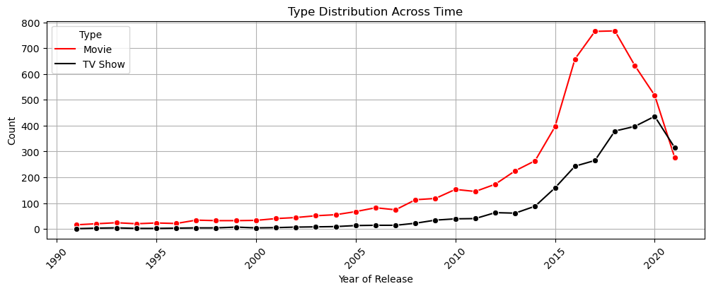

Insight 2
Analysis of the release and launch years of movies and TV shows on Netflix reveals a consistent upward trend in content creation until approximately 2012, followed by an explosive increase in production. This indicates that the creative industry experienced a peak between 2010 and 2018, suggesting that content consumption during this period reached unprecedented levels in history.

Insight 3
Since 2019, content creation has declined, likely due to the impact of COVID-19. However, this trend may not be detrimental for a platform like Netflix, this is a chance for the company to move out of their traditions content platforms and explore other areas of entertainment like:
  - Sports: Live sports and sports-related content resonate with a broad audience worldwide.
  - Online Game Streaming: Many online gamers have substantial audiences and brand partnerships, which can significantly enhance traction for the platform.

Let’s take a look at how the formats perform across different countries worldwide:
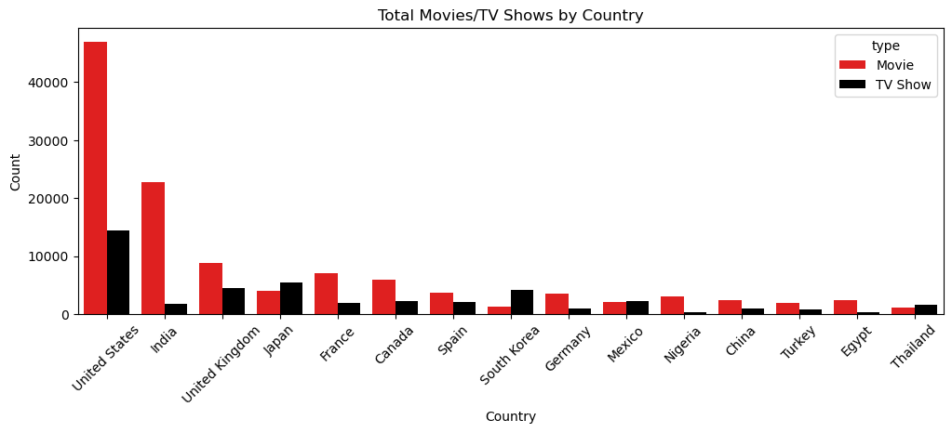

Insight 4
The U.S. remains the largest content consumer on Netflix, and we should continue to capitalize on our market share in this region. Meanwhile, Asian and European countries present significant opportunities for expanding our subscriber base. As semi-developed countries experience an internet boom, we can expect growth in various parts of the world. Although we face competition from platforms like HBO, Amazon Prime, and Hulu, adopting a first-mover strategy in these emerging markets will allow us to tap into a vast, untapped audience.
Suggestion: Netflix should actively participate in internet expansion campaigns globally. This involvement will not only help create new markets but also foster a sentimental connection with the growth stories of various nations.
Now, we will explore the durations of the content available on Netflix.


Insight 5
Movies on Netflix showcase a wide range of durations, from a few minutes to over four hours, indicating that audiences are comfortable with varying lengths. In contrast, TV shows reveal a distinct trend, with producers favoring mini-series of one season. Audiences seem to prefer these shorter formats, typically comprising 1 to 3 episodes, as they provide enough time to convey the intended story. While longer TV shows, particularly sitcoms, can engage viewers over multiple seasons, creating a stable and long-term audience base, mini-series offer a concise storytelling approach that appeals to modern viewers.

Directors:
Directors are foundational to the content industry, acting as the creative visionaries behind productions. Their insights significantly influence the artistic direction and quality of content. Understanding directors' preferences and styles is crucial for shaping the industry’s future, as their decisions impact storytelling techniques and audience engagement. Analysing these insights helps content creators make informed choices that resonate with viewers.

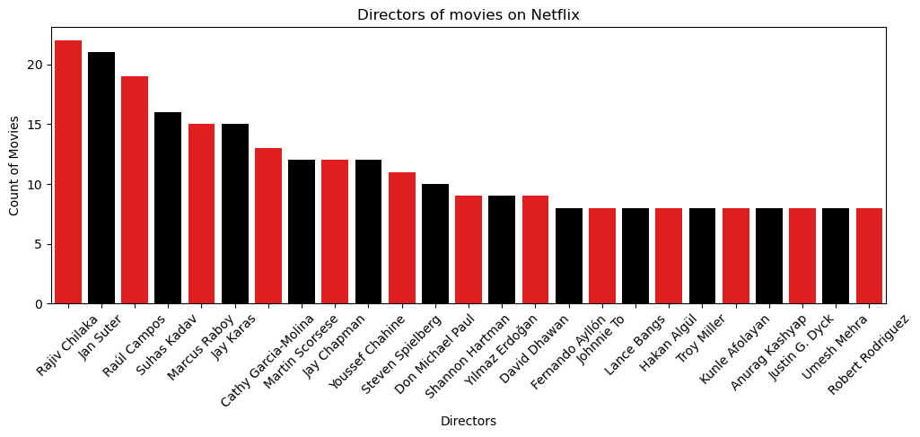
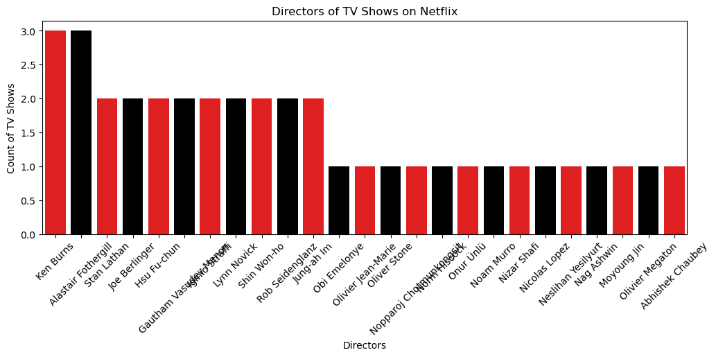

Insight 6
In the analysis of directorial contributions to our platform, it is evident that Rajiv Chilaka, Jan Suter, and Raul Campos have emerged as the leading figures in film direction, significantly shaping our cinematic offerings. Conversely, in the realm of television, Ken Burns and Alastair Fothergill stand out as the most influential directors, enhancing our programming with their exceptional storytelling. Together, these directors have played a pivotal role in defining the quality and impact of our content across both film and television.
Next, genre specialists will be discussed—directors who focus on specific genres and bring a unique style to their work.

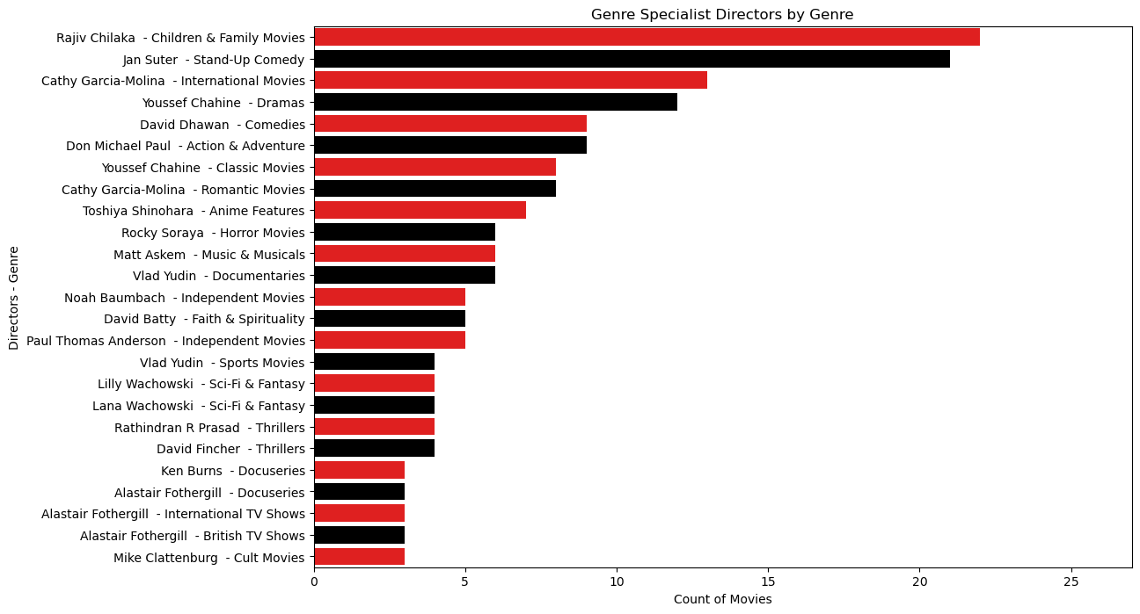

Insight 6
The chart above clearly highlights the leading directors for each genre of content on Netflix. We can conclude that films by these directors, within their areas of expertise, are likely to be more profitable additions to our platform, as they tend to attract a dedicated niche audience.

Actors:
Actors are essential to the content industry, serving as the key performers who bring stories to life. Their talent and interpretations profoundly influence the emotional resonance and appeal of productions. Understanding actors' preferences and styles is vital for shaping the industry's landscape, as their choices impact character development and audience connection. Analyzing these insights enables content creators to make informed casting decisions that enhance storytelling and engage viewers effectively.
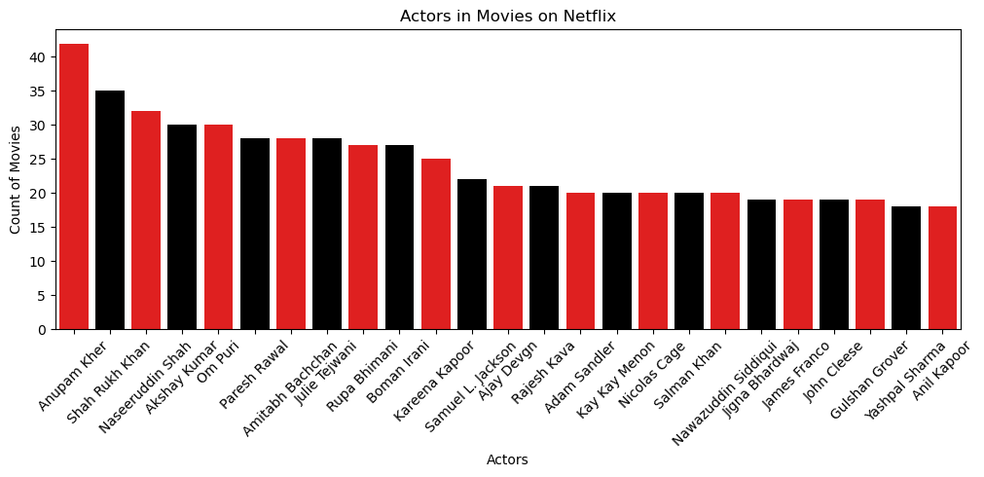
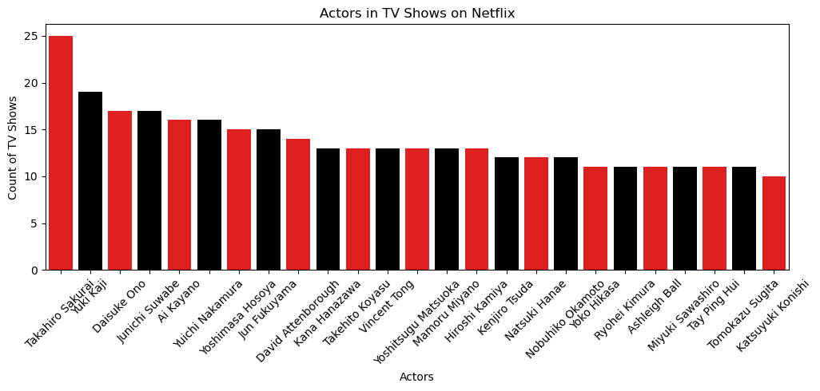

Insight 7
In assessing the contributions of actors to our platform, Anupam Kher, Shah Rukh Khan (SRK), and Naseeruddin Shah have emerged as the most prominent figures in film. Their performances have significantly enriched our movie offerings. On the television side, Takahiro Sakurai and Yuki Kaji have made the most substantial contributions, bringing depth and engagement to our TV shows. Recognizing these key actors is essential for understanding the strengths and appeal of our content across both mediums.
Next, we will focus on genre specialists—actors who excel in specific genres and bring a distinctive flair to their performances.
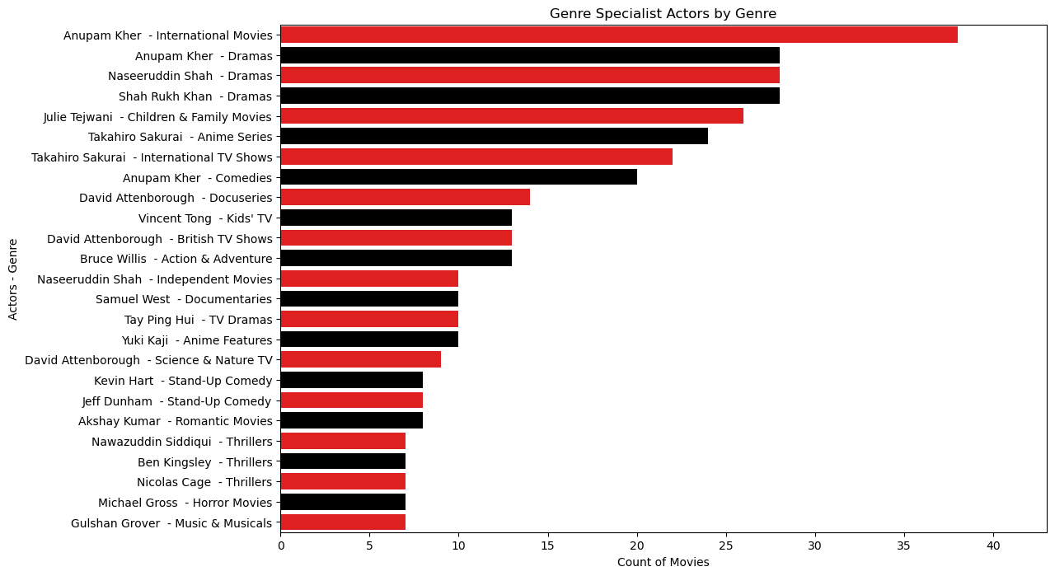

Insight 7
The chart above provides a clear view of the leading actors associated with each genre of content on Netflix. This indicates that films featuring these actors, especially within their preferred genres, have the potential to be highly profitable for our platform, as they tend to garner a dedicated and enthusiastic following.

Demographics:
Understanding which regions of the world prefer specific types of content and how these preferences adapt to our platform is essential for any study focused on customer behaviour and retention. Now, let’s delve into how cultural influences and platform adoption shape viewer behaviour.
Study of years in which content is added to a platform plays a vital role in shaping audience attraction and overall viewer growth. It serves as an indicator of the content production market in that region and reflects trends in viewer preferences.
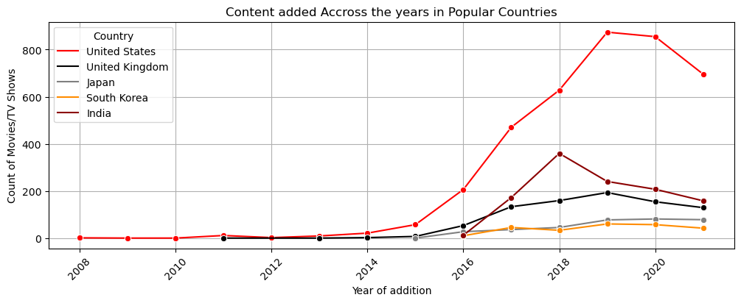

Insight 8
The chart reveals that the United States, as the origin country of Netflix, is the clear leader in content consumption. Notably, all countries show an upward trend beginning around 2015. Additionally, the Asia-Pacific region warrants focused attention, particularly in countries like India, South Korea, and Japan. These nations are hubs of diverse content creation and boast large populations, which translates to a significant user base and ample opportunities for developing and promoting local content.
Let’s explore which regions of the world prefer specific genres the most.
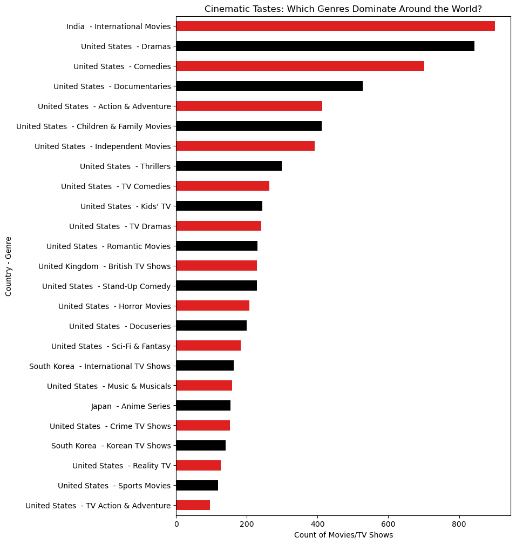

Insight 9
Understanding user preferences is essential for a company like Netflix, especially since regional factors influence emotional and cultural connections. It becomes imperative to analyze global viewership patterns. The chart above clearly illustrates these trends, highlighting how different communities favor distinct genres.

Ratings:
Movie and TV show ratings provide valuable insights into audience preferences and satisfaction, helping creators understand what resonates with viewers. Analyzing this data is crucial for guiding content development, marketing strategies, and improving overall viewer engagement.
Exploring the relationship between genres and ratings can reveal which types of content are more appealing and commercially viable. This analysis helps identify trends that inform content creation and marketing strategies, ultimately enhancing viewer satisfaction and profitability.

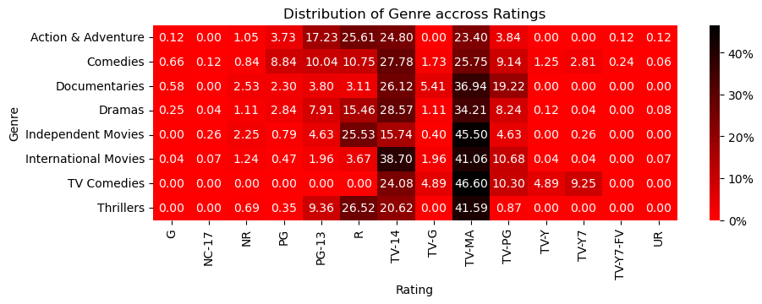

Insight 10
TV-MA Popularity: TV-MA is the most popular rating, indicating a strong preference among creators to produce content that appeals to a broad age range.
Genre Investment: Action & Adventure, Thrillers, and Comedies exhibit a wide range of ratings, suggesting that investing in these genres could be highly beneficial due to their larger audience base.
Now, let’s categorize the ratings into more easily understandable classes to facilitate analysis for the report's audience.
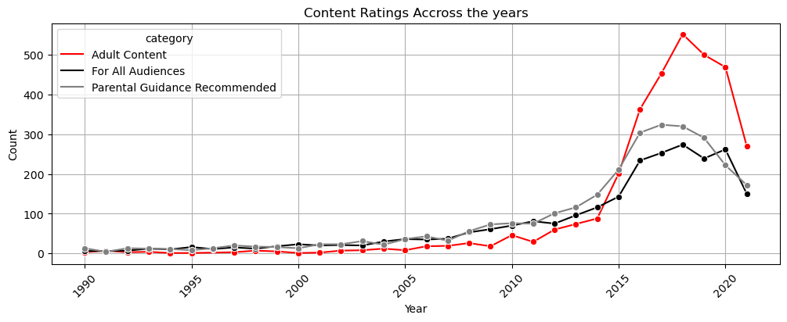

Insight 11
The chart above illustrates the trend of content ratings on the platform over the years. Notably, content classified as 'Adult' or inappropriate for children under 18 has seen significant surges in the past 5-6 years. This suggests that audiences are becoming more receptive to raw, unfiltered content and are increasingly expecting less sugarcoating in the material presented to them.
Suggestion: Children play a vital role in society, and their exposure to video content is crucial for shaping their minds, often making it a top priority for parents. Introducing a dedicated Kids section on the Netflix website and app would enhance the platform's suitability for younger audiences and increase its appeal among parents.
Finally, let’s examine the distribution of ratings among movies and TV shows:
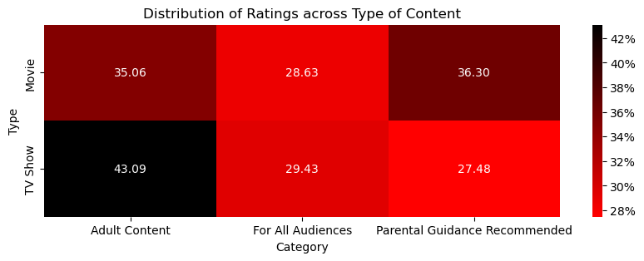

Insight 11
The chart above shows that nearly 70% of movies are suitable for audiences of all age groups. This aligns with the fact that the success of most films is largely determined by box office collections, which aim to reach the broadest audience possible.
In contrast, TV shows contribute over 43% of content classified as 'Adult,' along with more than 27% in the PG category. This highlights the maturity of the TV show and web series audience, reflecting the distinct goals of this longer format of content.

In conclusion, this report highlights the importance of understanding content ratings, viewer preferences, and genre trends on our platform. By analyzing these factors, we can make informed decisions that enhance audience engagement and optimize our content offerings. As we continue to adapt to shifting viewer demands and cultural influences, our focus on diverse and high-quality programming will be key to driving growth and satisfaction among our user base.

